- Various Transactions Involving Liabilities (Chapters 13-14) Englewood Biotechnology Corporation began operations in September 2012. The following selected transactions relate to the liabilities of the company for the period September 2012 through March 2013. Englewood’s fiscal year ends December 31, and its financial statements are issued in April.
2012
  - On October 1, borrowed $12 million cash from First Jersey Bank and issued a five-month promissory note. Interest at 10% was payable at maturity and all of the principal were payable at maturity. Management planned to issue 10-year bonds in February 2013 to repay this note

10/1/12 | Cash |  | $12,000,000
 |  | Note Payable |  | $12,000,000

  - Received $2,600 of refundable deposits in December for reusable containers used to transport and store chemical-based products.

12/31/12 | Cash |  | $2,600
 |  | Refundable Deposit |  | $2,600

  - For the September-December period, sales on account totaled $4,100,000. The combined state and local sales tax rate is 6%. (This is a summary journal entry for the many individual sales transactions with customers during the period.)

12/31/12 | Accounts Receivable |  | $4,346,000
 |  | Sales Tax Payable |  | $246,000
 |  | Sales Revenue |  | $4,100,000

  - Recorded the adjusting journal entry for accrued interest.

12/31/12 | Interest Expense (3 months)(12,000,000 x .10 x 3/12) |  |  | $300,000
 |  | Interest Payable |  |  | $300,000

2013
  - On February 1, issued $10 million of 10-year bonds at face value.

2/1/13 | Cash |  | $10,000,000
 |  | Bonds Payable |  | $10,000,000

  - On the March 1 maturity date, paid all amounts due on the bank loan.

3/1/13 | Interest Payable (3 months) |  | $300,000
 | Interest Expense (2 months) (12,000,000 x .10 x 2/12) |  |  | $200,000
 | Note Payable |  | $12,000,000
 |  | Cash |  |  | $12,500,000

  - Half of the storage containers covered by refundable deposits were returned in March. The remaining containers are expected to be returned during the next 6 months.
3/1/13 | Refundable Deposit |  | $1,300
 |  | Cash |  | $1,300

  - On March 15, the attorney for one of Englewood’s laboratory employees notified management that the worker had been injured on the job on January 15, and planned to sue the company for $500,000. Management and the employee agreed on a settlement, with the company paying the employee $150,000 on March 30. (Make one journal entry for this lawsuit, as of March 30.

3/15/13 | Lawsuit Loss |  | $150,000
 |  | Cash |  | $150,000

Required:
- Prepare the current and long-term liability sections of the December 31, 2012 Balance Sheet, in good form. (Note: Also include Accounts Payable of $202,000 and Accrued Payroll Liabilities of $50,000 in the Current Liabilities section.)

 |  | Englewood Biotechnology Corporation
 |  | Partial Balance Sheet
 |  | December 31, 2012
Current Liabilities:
 | Accounts Payable |  |  | $202,000
 | Accrued Payroll Liabilities |  |  | 50,000
 | Note Payable |  |  | 12,000,000
 | Refundable Deposit |  |  | 2,600
 | Sales Tax Payable |  |  | 246,000
 | Interest Payable |  |  | 300,000
 |  |  | Total Current Liabilities: | $12,800,600
Long Term Debt:
 | Notes Payable refinanced in January 2013 |  |  | $10,000,000
 |  | Total Long Term Debt: |  | $10,000,000

- Questions Pertaining to the Financial Statements of Apple, Inc. for Fiscal 2012 (Year Ended September 29, 2012): Refer to the excerpts of Apple’s annual report on Form 10-K for its fiscal year 2012, which will be distributed in a separate handout.
  - Accounting for Warranties:
    - Apple’s revenue recognition footnote, on its page 48, discusses how it accounts for revenue from AppleCare service and support contracts.
      - What services and support are provided to customers under these contracts?

AppleCare service and support contracts typically include extended phone support, repair services, web-based support resources and diagnostic tools offered under the Company’s standard limited warranty.

      - When does Apple recognize revenue from these contracts? On what line(s) in the Balance Sheet is it reported until it is recognized in revenue?

AppleCare and support contract revenue is deferred and recognized over the service period coverage periods. It is recorded as an accrued expense under current liabilities until it is recognized revenue

      - The textbook describes two types of accrual accounting methods for warranties. Which method is used by Apple for these AppleCare service and support contract?

While Apple has a general liability that is included with their products that would be considered an expense warranty approach, the AppleCare services are accounted for using the Sales-Warranty approach. The AppleCare plan is sold separately from the product and requires that revenues from the sale of warranty be deferred and subsequently recognized as income over the life of the warranty contract.

    - In Note 7 – Commitments and Contingencies, Apple describes its various “basic” warranties on its products sold to customers, and “basic” warranties covering service parts used to repair hardware products.
      - What is the warranty period for each of these two types of basic warranties? (How many days or years are covered?)

Basic Warranties for Products – 1 Year
Basic Warranties for Service Parts – 90 Days

      - How does Apple account for the expense and related liability pertaining to these basic warranties? (Also read “Warranty Expense” footnote on page 49.)
Apple estimates the cost that may be incurred by using historical and projected warranty claim rates, historical and project cost-per-claim, and knowledge of specific product failures that are outside of the Company’s typical experience.

      - Using the information in the table in Note 7, give Apple’s two “summary” journal entries in Fiscal 2012 pertaining to these basic warranties. (Hint: Refer to “Notes on Homework Exercise 13-11-Warranties” part a, alternative journal entries.)

12/31/12 | Warranty Expense |  | $1,786,000,000
 |  | Inventory, Cash and Accrued Payroll |  | $1,786,000,000
 | Warranty Expense |  | $2,184,000,000
 |  | Warranty Liability ($2,184 - 1,786) |  | $2,184,000,000

      - In what line on the Balance Sheet is the $1,638 of “Accrued Warranty and Related Costs” included?

It can be found in the Accrued expenses portion of the current liabilities. Footnote # 3, page 59.

  - As discussed in the “Revenue Recognition” footnote, page 48, Apple sells gift cards that can be redeemed at its retail stores and online stores.
    - Summarize Apple’s accounting policy for gift cards.

“The Company records deferred revenue upon the sale of the card, which is relieved upon redemption of the card by the customer.”

    - In what line(s) in the Balance Sheet does Apple report any unredeemed gift cards?

Apple Reports any unredeemed liabilities in the deferred revenue section of the current liabilities portion, as well as any non-current gift cards as deferred revenue – non-current. This appears on page 44 of the financial statements.

  - Accounting for Contingencies: Apple provides a footnote summary of its lawsuit against Samsung Electronics.

    - What type of contingency exists – a loss contingency, or a gain contingency?

A gain contingency exists because according to the financial statements “On August 24, 2012, a jury returned a verdict awarding the Company $1.05 billion in its lawsuit against Samsung Electronics and affiliated parties in the United States District Court, Northern District of California, San Jose Division. Because the award is subject to entry of final judgment and may be subject to appeal, the Company has not recognized the award in its consolidated financial statements for the year ended September 29, 2012.”

    - Has Apple recognized the $1.05 billion jury award in its fiscal 2012 financial statements? Give the accounting reason justifying Apple’s accounting treatment. (Explain why Apple has recognized it or why Apple has not recognized it.)

Gain Contingencies are not recorded and are disclosed only when the probabilities are high that the gain contingency will become a reality. (Lecture notes chapter 13 page 6)

Relevance is one of the fundamental qualities of the conceptual framework. To be relevant, accounting information must be capable of making a difference in a decision Financial information has predictive vale if it has a value as an input to predictive processes used by investors to form their own expectations about the future. (chapter 2, pg 48 of text). In accordance with the rules of the conceptual framework, we want to be conservative in what we are reporting.

- Questions based on Proctor & Gamble’s Fiscal 2009 annual financial statements. The textbook includes excerpts for the Proctor & Gamble annual financial statements for Fiscal 2009. P&G’s fiscal year ends June 30 each year. (See pages 246-277 of textbook.)
  - In Note 10, in the “Litigation” section, the company discusses at length (in the 2nd and 3rd paragraphs) the ongoing investigations of various companies by the European Commission and European national authorities into potential violations of competition laws. At the time the financial statements were published, P&G states that no significant formal claims have been made against the company or its subsidiaries in connection with these investigations. However, P&G management initiated its own internal investigation.
    - Has P&G accrued any amounts in connection with violations it has discovered?

No, as the text reads, “No significant formal claims have been made against the Company” and “It is still to early for us to reasonably estimate the fines to which the Company will be subject as a result of these competition law issues.” (page 273 of text)

    - Review the accounting and disclosure rules summarized in the Chapter 13 Outline for these types of unasserted claims and assessments. Analyze whether each requirement for accrual or disclosure was met or not met.

Based on the note section of the financial statements, “the ultimate resolution of these matters will likely result in fines or other costs that could materially impact our income statement and cash flows in the period in which they are accrued and paid, respectively.” Therefore, we determined that the contingent liability is reasonably possible. While the event is likely to result in a material impact of financial statements, at this time, it can not be estimated. Therefore, a footnote disclosure of that nature of the loss contingencies is necessary, and that is what the company did.

  - Examine the Balance Sheet to determine the number of shares of common stock in each category as of the end of Fiscal 2009. Note that P&G expresses number of shares in “millions of shares” on the Balance Sheet— so use this unit of measure—do not add any zeroes. Also note that you will have to calculate some of the numbers below—remember to show any calculations.

- Number of shares issued: 4,007.3 million shares
- Number of shares outstanding: (Issued shares – Treasury stock held) 4,007.3 – 1,090.3 = 2,917 million shares
- Number of shares of treasury stock held: 1,090.3 million shares
- Number of unissued shares: (Authorized shares – issued shares) 10,000 – 4,007.3 = 5,992.7 million shares

- Accounting for Bonds – Issuer’s Accounting - Chapter 14 Given: On July 1, 2011, Regents Corp. issued bonds that have a face value of $900,000 and a stated interest rate of 6%. Interest is paid semi-annually each June 30 and December 31, and the bonds mature in 4 years, on June 30, 2015. For bonds of similar risk and maturity, the market yield on the date of issuance was 5%.
  - Calculate the semi-annual coupon payment. (Show your work to get credit.)

900,000 * .06 / 2 = 27,000

  - Calculate the issue price of the bonds. Show your detailed calculations, including the separate calculation of the present value of the principal and present value of the interest, to get credit.

Bond - $900,000 (x) 0.82075 = $738,675
Coupon - $27,000 (x) 7.17014 = $193,593.78
= $932,268.78

  - Complete the amortization schedule below, through at least Dec. 31, 2012, using the effective interest method. (Note: You may wish to complete the entire amortization schedule as a proof of your work, but the areas shaded in gray are not required.)

Date | Cash Interest (coupon) | Interest Revenue or expense | Amortization of the Discount or Premium | Bond Carrying Value
7/1/11 | $- | $- | $- | $932,269
12/31/11 | $27,000 | $23,307 | $3,693 | $928,575
6/30/12 | $27,000 | $23,214 | $3,786 | $924,790
12/31/12 | $27,000 | $23,120 | $3,880 | $920,910
6/30/13 | $27,000 | $23,023 | $3,977 | $916,932
12/31/13 | $27,000 | $22,923 | $4,077 | $912,856
6/30/14 | $27,000 | $22,821 | $4,179 | $908,677
12/31/14 | $27,000 | $22,717 | $4,283 | $904,394
6/30/15 | $27,000 | $22,610 | $4,390 | $900,004

Regent’s accounting (Issuer) in 2011:

    - Prepare Regent’s journal entry for July 1, and give a description (purpose of) the entry.
The purpose of the entry is to account for the issuance of the bond.

7/1/11 | Cash (+A) |  | $932,269
 |  | Premium On Bonds Payable (+L) |  | $32,269
 |  | Bonds Payable (+L) |  | $900,000

    - Prepare Regent’s journal entry for Dec. 31, and give a description (purpose of) the entry.
The purpose of the entry is to account for the semi-annual coupon payments.

12/31/11 | Interest Expense (+E) |  | $23,307
 | Premium On Bonds Payable (-L) |  | $3,693
 |  | Cash (-A) |  | $27,000

    - Complete the following to show the value of Regent’s total (net) bond liability reported on its Balance Sheets at the following dates:
 |  | 12/31/11 | 12/31/12
Bonds Payable |  | $900,000 | $900,000
Unamortized Premium on Bonds Payable |  | $28,575 | $20,910
 | Bonds Payable, Net | $928,575 | $920,910

  - Accounting for early retirement (redemption, or extinguishment) of bonds: Now, assume that on Jan. 1, 2013, Regent calls the entire bond issue at 102 (102% of par value) and cancels the bonds.
    - Calculate Regent’s gain or loss from retirement of the bonds.

Book Value on 12/31/12 as shown above: $920,910
Reacquisition Price (102% of $900,000 par value): $918,000
Gain ($920,919 - $918,000): $2,910

    - Record Regent’s journal entry to record this retirement of bonds on January 1, 2013.

1/1/13 | Bonds Payable (-L) |  |  | $900,000
 | Premium on Bonds Payable (-L) |  |  | 20,910
 |  | Cash (-A) |  |  | 918,000
 |  | Gain on Retirements of Bonds (+R) |  |  | 2,910

- Issuer’s Accounting for Bonds (Interest payment dates do not coincide with financial reporting dates.) Given: On April 1, 2012, Middleton Corp. issued bonds that have a face value of $200,000 and a stated interest rate of 8%. Interest is paid semi-annually each September 30 and March 31, and the bonds mature in 2 years, on March 31, 2014. For bonds of similar risk and maturity, the market yield on the date of issuance was 10%.
  - Calculate the semi-annual coupon payment. (Show your work to get credit.)

$200,000 (x) .08 / 2 = $8,000

  - Calculate the issue price of the bonds. Support your calculations.

Bond - $200,000 (x) 0.82270 = $164,540
Coupon - $8,000 (x) 3.54595 = $28,367.60
=$192,907.60

  - Complete the amortization schedule below, using the effective interest method.

Date | Cash Interest (coupon) | Interest Revenue or expense | Amortization of the Discount or Premium | Bond Carrying Value
4/1/12 | $8,000 | $- | $- | $192,908
9/30/12 | $8,000 | $9,645 | $1,645 | $194,553
3/31/13 | $8,000 | $9,728 | $1,728 | $196,281
9/30/13 | $8,000 | $9,814 | $1,814 | $198,095
3/31/14 | $8,000 | $9,905 | $1,905 | $199,999

  - Middleton’s accounting from issuance through maturity – Give ALL necessary entries including dates and description/purpose.

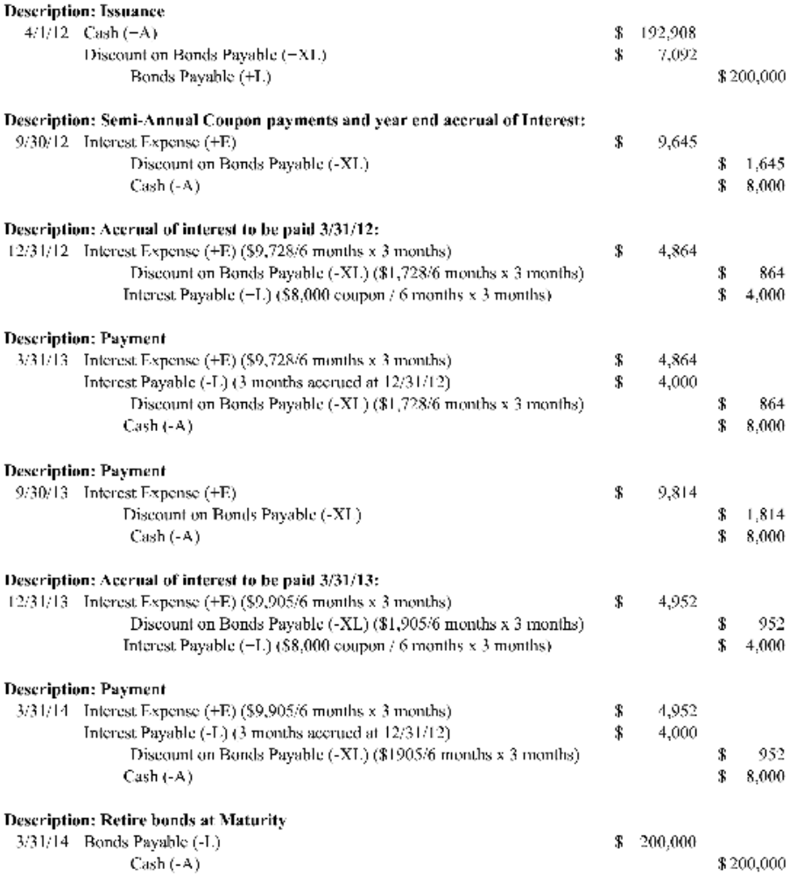

- Non-Interest Bearing Note – Chapter 14
On December 31, 2012, Mount Vernon, Inc. issued a $150,000 non-interest bearing note to Washington Corp. due on December 31, 2014. (Mount Vernon must pay Washington $150,000 on December 31, 2014.)

The note was given in exchange for consulting services rendered during the last quarter of 2012 by Washington Corp. to Mount Vernon, Inc. The fair value of the services rendered is not readily determinable. The market rate of interest for a note of this type and risk level was 9% as of January 1, 2013. Washington recently had to pay 7% for money it borrowed from Bank of Virginia. Washington’s collection of the note receivable from Mount Vernon is reasonably assured.
  - Give the journal entry on Mount Vernon’s books on December 31, 2012 to record the issuance of the note to Washington. Show any necessary calculations.
Notes Receivable (+A) ($150,000 *.84168, when n=2, i= 9%) |  | $126,252
Discount on Notes Receivable (+XA) |  | $23,748
 | Consulting Services (-A) |  |  | $150,000

  - Complete the amortization table for this note. (Round to the nearest whole dollar.)

 | Beginning of Period Carrying Value of Note | Cash Interest Received | Interest Revenue Earned | Discount Amortization | End of Period Carrying Value of Note
12/31/12 | $- | $- | $- | $- | $126,252
12/31/13 | $126,252 | $- | $11,363 | $11,363 | $137,615
12/31/14 | $137,615 | $- | $12,385 | $12,385 | $150,000

  - Give all remaining journal entries required to be made by Mount Vernon, for 2013 and 2014. Give dates and label each entry to show its purpose.
Description: Issuance
12/31/12 | Cash (+A) |  | $126,252
 | Discount on Bonds Payable (+XL) |  | $23,748
 |  | Note Payable (+L) |  | $150,000
Description: Year end accrual of Interest
12/31/13 | Interest Expense (+E) |  | $11,363
 |  | Discount on Note Payable (-XL) |  | $11,363
Description: Year end accrual of Interest
12/31/14 | Interest Expense (+E) |  | $12,385
 |  | Discount on Note Payable (-XL) |  | $12,385
Description: Retire note at Maturity
12/31/14 | Note Payable (-L) |  | $150,000
 |  | Cash (-A) |  | $150,000

